Steps to Enroll in the ELPS Academy
On the screen showing Activation Complete, you will see a Search Courses button (top). Enter ELPS Academy. You will see ELPS Academy on the fifth row. Click on it. You will see the following screen-----Click on enroll in ELPS Academy. 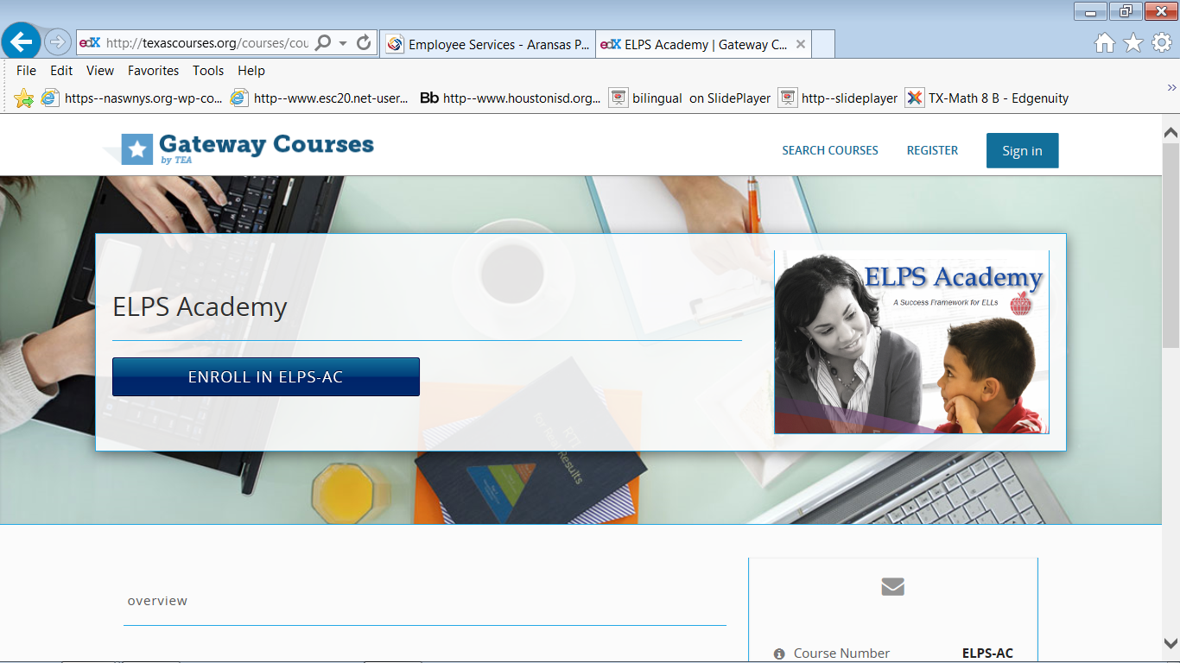
You will see this screen ----Click on View Course.
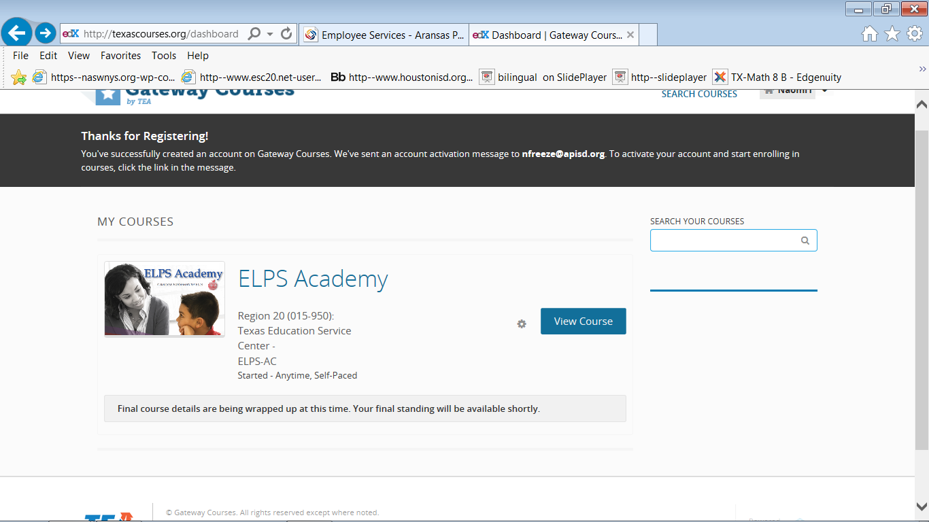
Steps to find Course Lessons
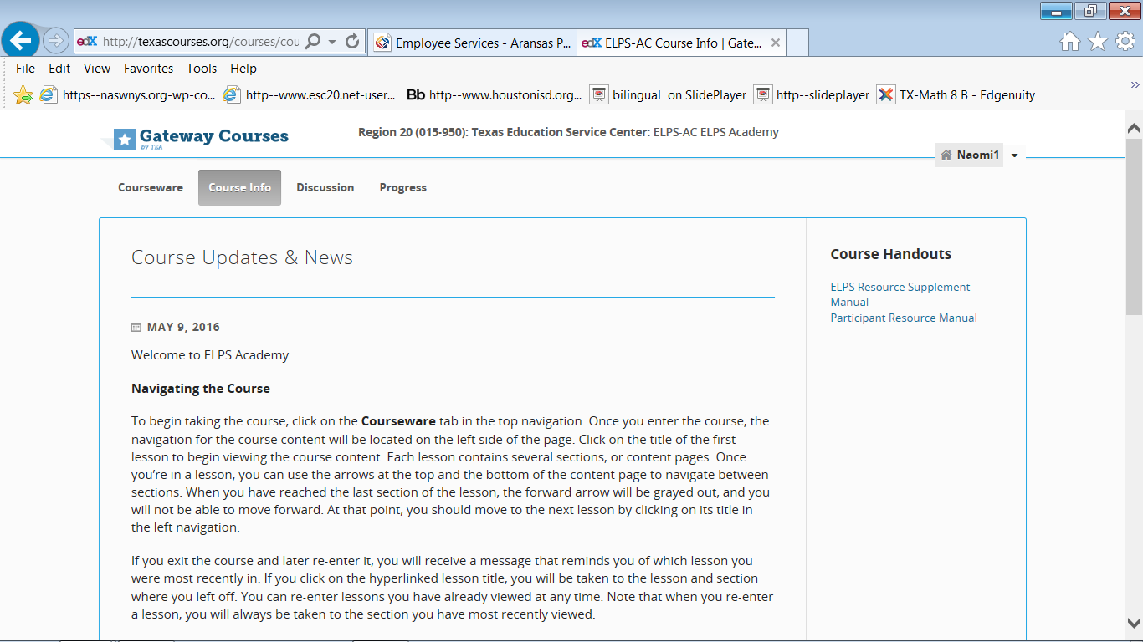 See this screen; review participant’s manual. On this page you will click on Progress to get to course. The screens below are one page; you will scroll down to click on lessons. Course is self-paced.

